DSA0603 Data Handling and Visualization
CO2 - Assessment Test 6 (AT3) - Case Study
Install Packages and Load Libraries (used across all case studies)
# Install packages if missing
if (!require(ggplot2)) install.packages("ggplot2")
if (!require(dplyr)) install.packages("dplyr")
if (!require(reshape2)) install.packages("reshape2")
if (!require(igraph)) install.packages("igraph")
# Load libraries
library(ggplot2)
library(dplyr)
library(reshape2)
library(igraph)
Case Study 1 - Retail Sales Performance Dashboard
Visualization Selection
• Bar Plot - Compare total revenue across regions.
• Stacked Bar Chart - Show product category contribution per region.
• Histogram - Show distribution of sales revenue.
• Density Plot - Compare revenue spread across regions.
• Scatter Plot - Show advertising spend vs revenue relationship.
R Program
set.seed(101)
regions <- c("North","South","East","West","Central")
categories <- c("Electronics","Clothing","Groceries","Furniture")
sales_data <- data.frame(
Region = sample(regions, 60, replace = TRUE),
Category = sample(categories, 60, replace = TRUE),
AdSpend = round(runif(60, 5, 50), 1))
sales_data$Revenue <- round(sales_data$AdSpend * runif(60, 4, 9) + rnorm(60, 50, 20), 1)
sales_data$Revenue[sales_data$Region == "North"] <- sales_data$Revenue[sales_data$Region == "North"] + 80
region_revenue <- sales_data %>% group_by(Region) %>% summarise(TotalRevenue = sum(Revenue))
ggplot(region_revenue, aes(reorder(Region, -TotalRevenue), TotalRevenue, fill = Region)) +
geom_bar(stat = "identity") + labs(title = "Total Revenue by Region", x = "Region", y = "Total Revenue")
region_cat <- sales_data %>% group_by(Region, Category) %>% summarise(Revenue = sum(Revenue))
ggplot(region_cat, aes(Region, Revenue, fill = Category)) + geom_bar(stat = "identity", position = "stack") +
labs(title = "Revenue by Region and Category", x = "Region", y = "Revenue")
ggplot(sales_data, aes(Revenue)) + geom_histogram(binwidth = 40, fill = "steelblue", color = "black") +
labs(title = "Distribution of Sales Revenue", x = "Revenue", y = "Frequency")
ggplot(sales_data, aes(Revenue, fill = Region)) + geom_density(alpha = 0.4) +
labs(title = "Revenue Density by Region", x = "Revenue", y = "Density")
ggplot(sales_data, aes(AdSpend, Revenue)) + geom_point(color = "darkorange") +
geom_smooth(method = "lm", se = FALSE, color = "black") +
labs(title = "Advertising Spend vs Revenue", x = "Ad Spend", y = "Revenue")
Generated Visualizations
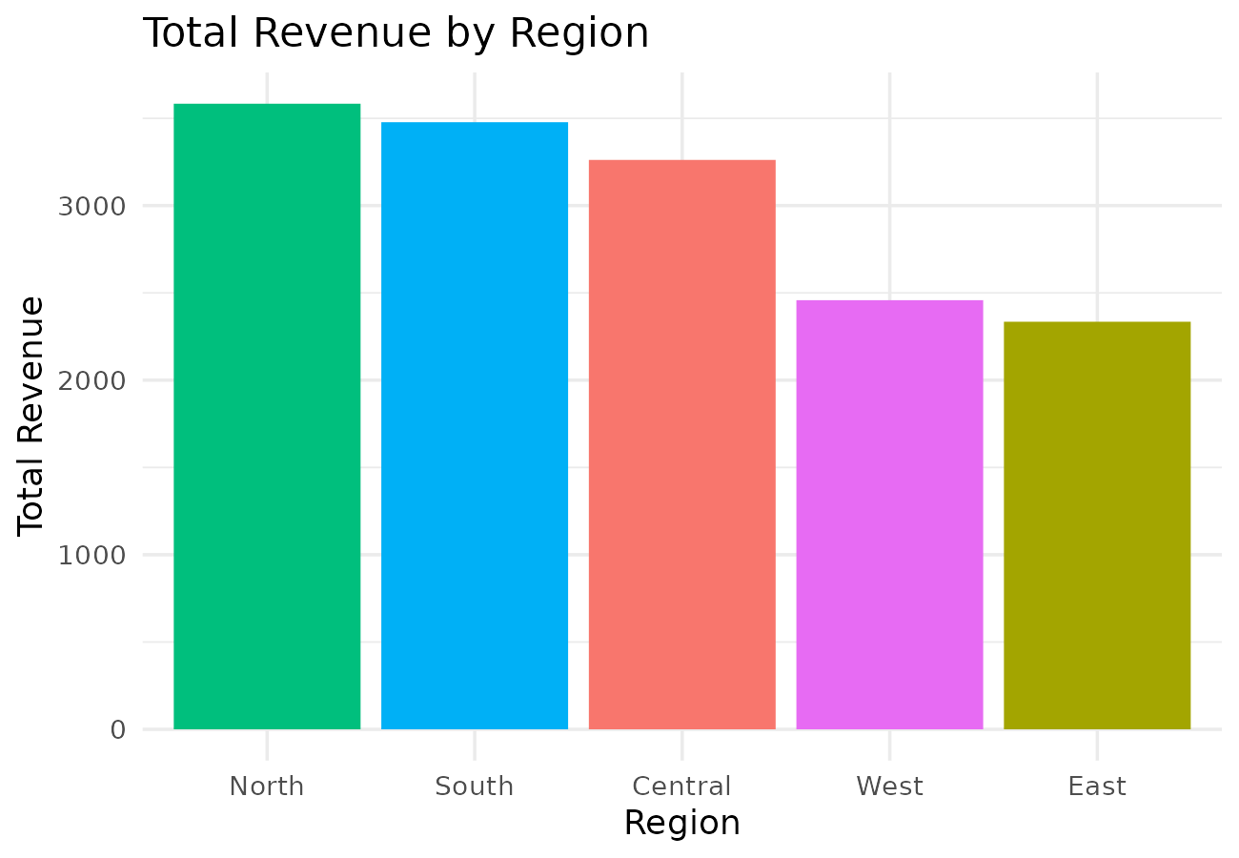 | 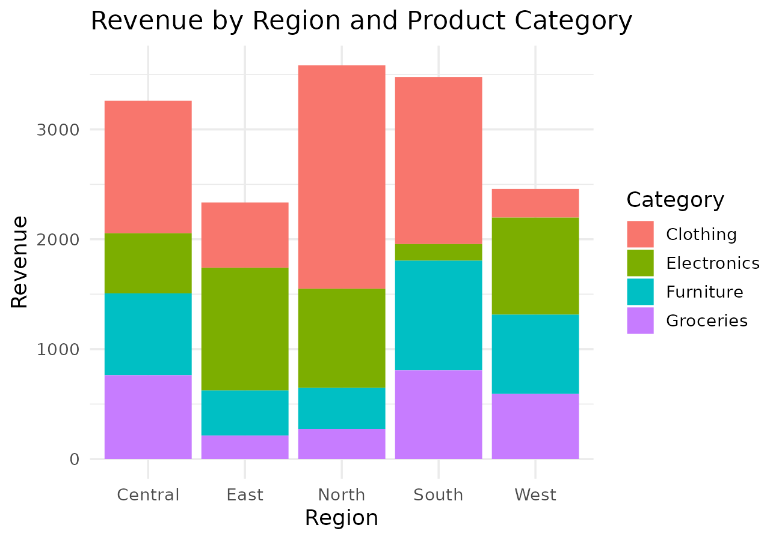
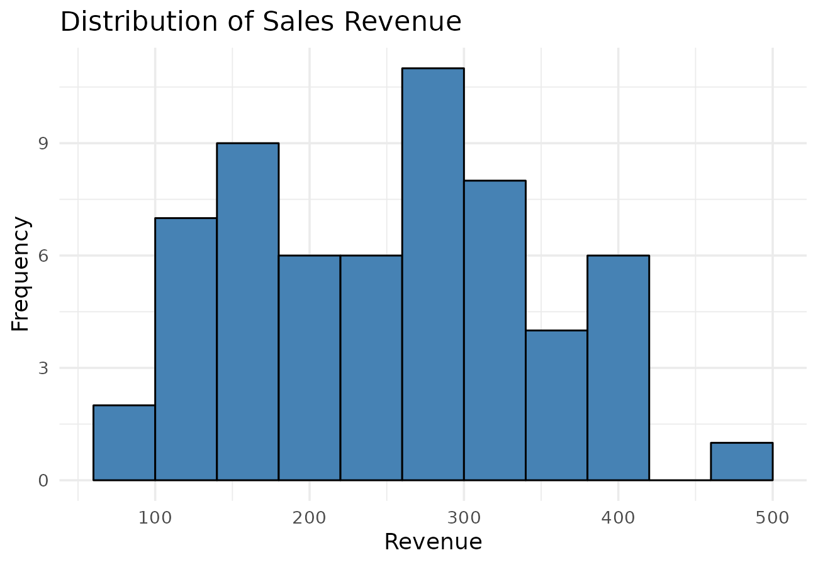
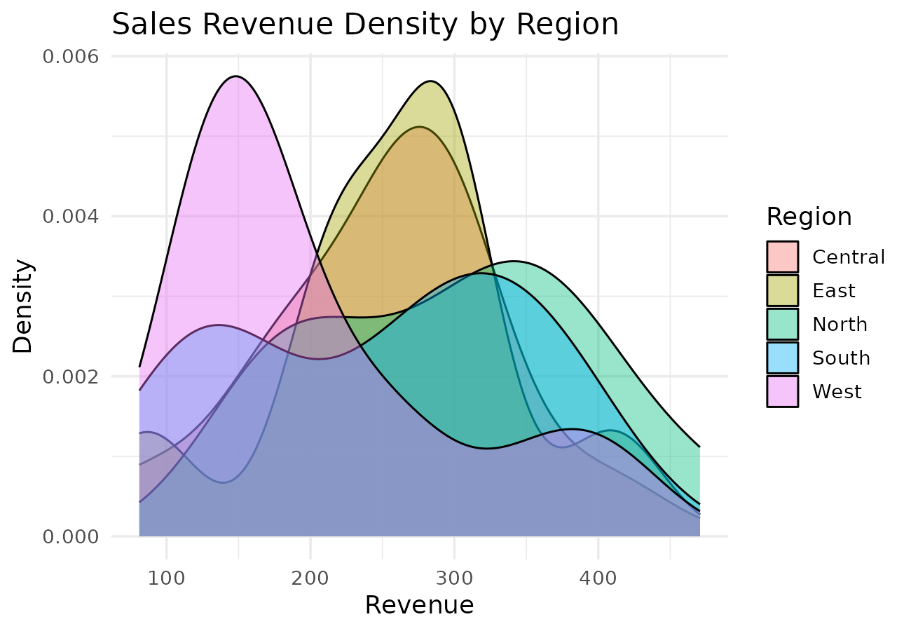 | 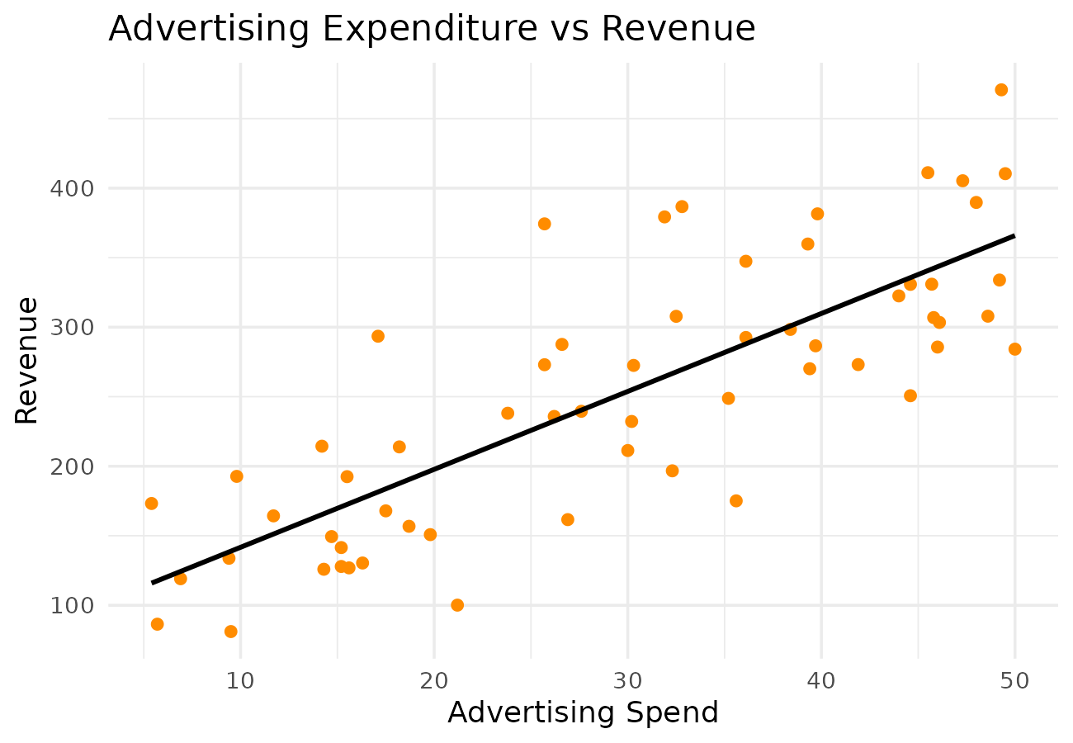
Interpretation
North generated the highest total revenue among the five regions. Advertising expenditure and revenue show a strong positive relationship (r = 0.80). Clothing contributes the highest percentage of revenue among the four categories.
Case Study 2 - University Student Performance Analysis
Visualization Selection
• Grouped Bar Chart - Compare average marks by department.
• Violin Plot - Show CGPA distribution shape by department.
• Histogram with Density Curve - Show attendance distribution.
• Scatter Plot - Show attendance vs CGPA relationship.
• Line Chart - Show semester-wise performance trend.
R Program
set.seed(202)
departments <- c("Computer Science","Information Technology","Electronics","Mechanical")
n_per_dept <- 30
students <- data.frame(Department = rep(departments, each = n_per_dept),
Attendance = round(runif(n_per_dept * 4, 60, 100), 1))
dept_shift <- c("Computer Science"=0.5,"Information Technology"=0.2,"Electronics"=0,"Mechanical"=-0.2)
students$CGPA <- round(pmin(10, pmax(4, 4 + (students$Attendance-60)/40*5 +
dept_shift[students$Department] + rnorm(nrow(students), 0, 0.4))), 2)
students$Placed <- ifelse(students$CGPA > 7.5 & students$Attendance > 75, "Placed", "Not Placed")
sem_data <- expand.grid(Semester = 1:8, Department = departments)
sem_data$AvgMarks <- round(60 + sem_data$Semester*2 + dept_shift[sem_data$Department]*10 +
rnorm(nrow(sem_data), 0, 2), 1)
avg_marks_grouped <- sem_data %>% mutate(Group = ifelse(Semester<=4,"Sem 1-4","Sem 5-8")) %>%
group_by(Department, Group) %>% summarise(AvgMarks = mean(AvgMarks))
ggplot(avg_marks_grouped, aes(Department, AvgMarks, fill = Group)) + geom_bar(stat="identity", position="dodge") +
labs(title = "Department-wise Average Marks", x = "Department", y = "Average Marks")
ggplot(students, aes(Department, CGPA, fill = Department)) + geom_violin(trim = FALSE) +
labs(title = "CGPA Distribution by Department", x = "Department", y = "CGPA")
ggplot(students, aes(Attendance)) + geom_histogram(aes(y = after_stat(density)), binwidth = 5, fill = "skyblue", color = "black") +
geom_density(color = "darkred") + labs(title = "Attendance Distribution", x = "Attendance (%)", y = "Density")
ggplot(students, aes(Attendance, CGPA, color = Department)) + geom_point() +
labs(title = "Attendance vs CGPA", x = "Attendance (%)", y = "CGPA")
ggplot(sem_data, aes(Semester, AvgMarks, color = Department)) + geom_line() + geom_point() +
labs(title = "Semester-wise Marks Trend", x = "Semester", y = "Average Marks")
Generated Visualizations
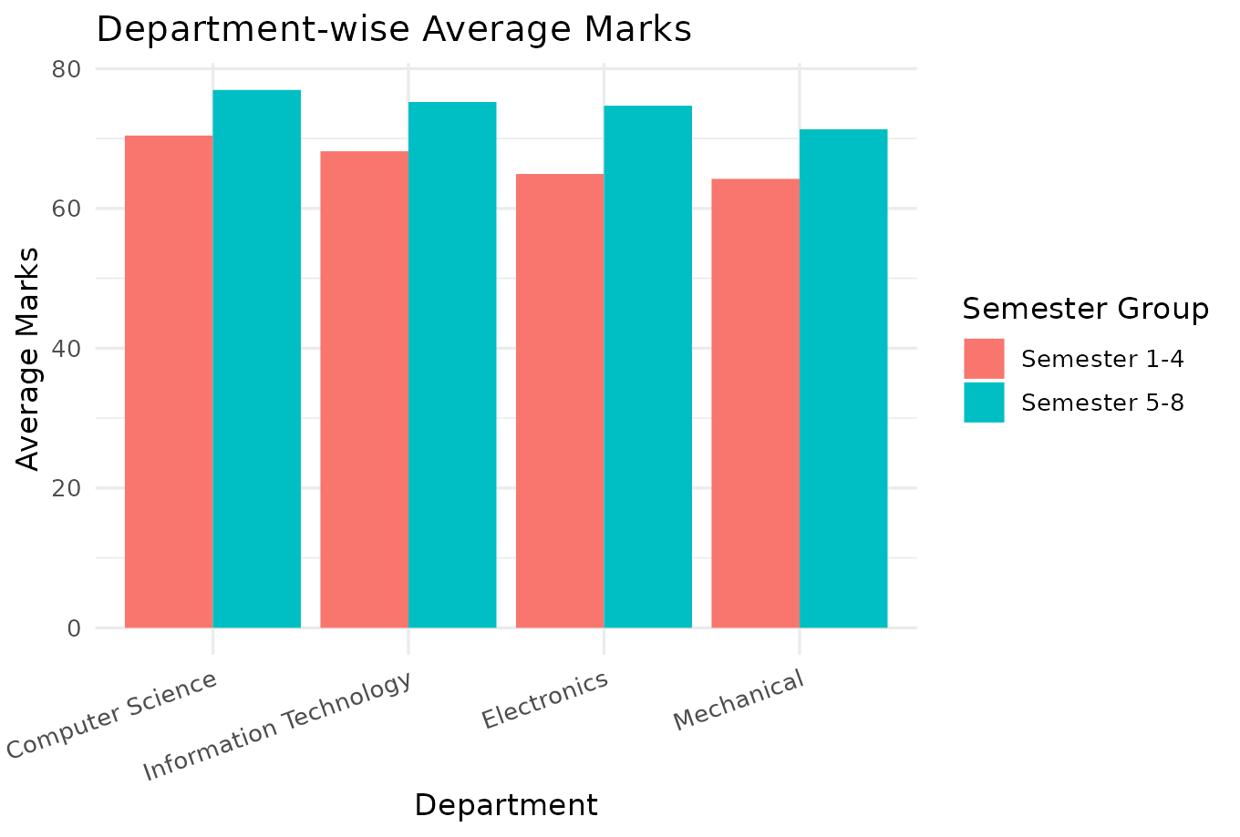 | 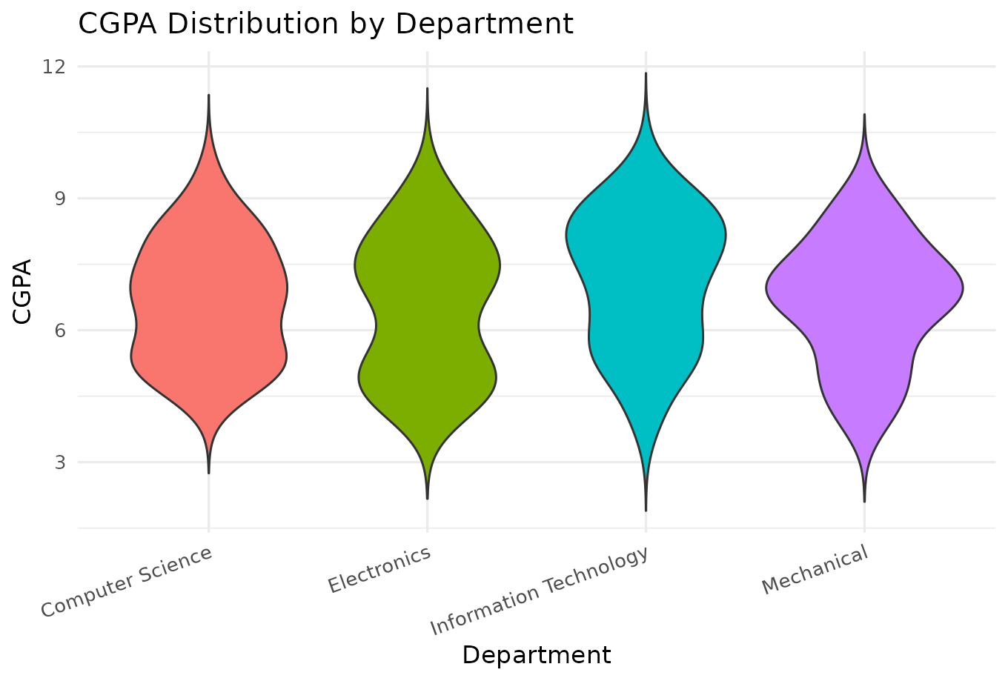
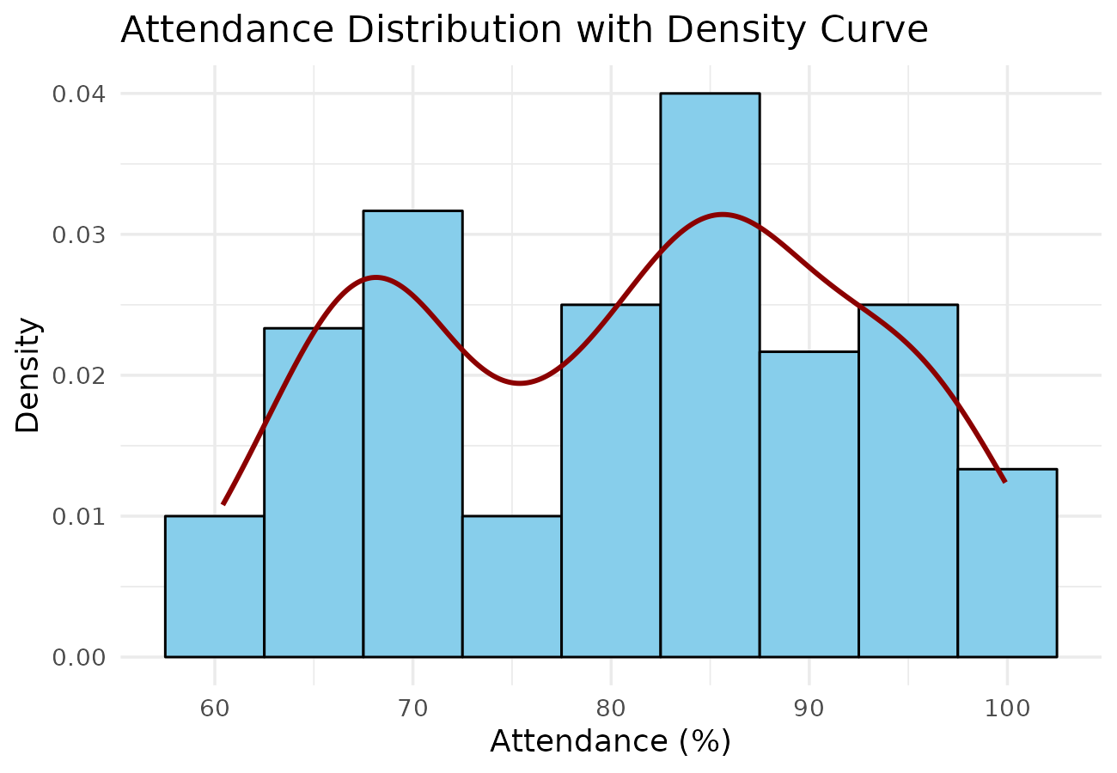
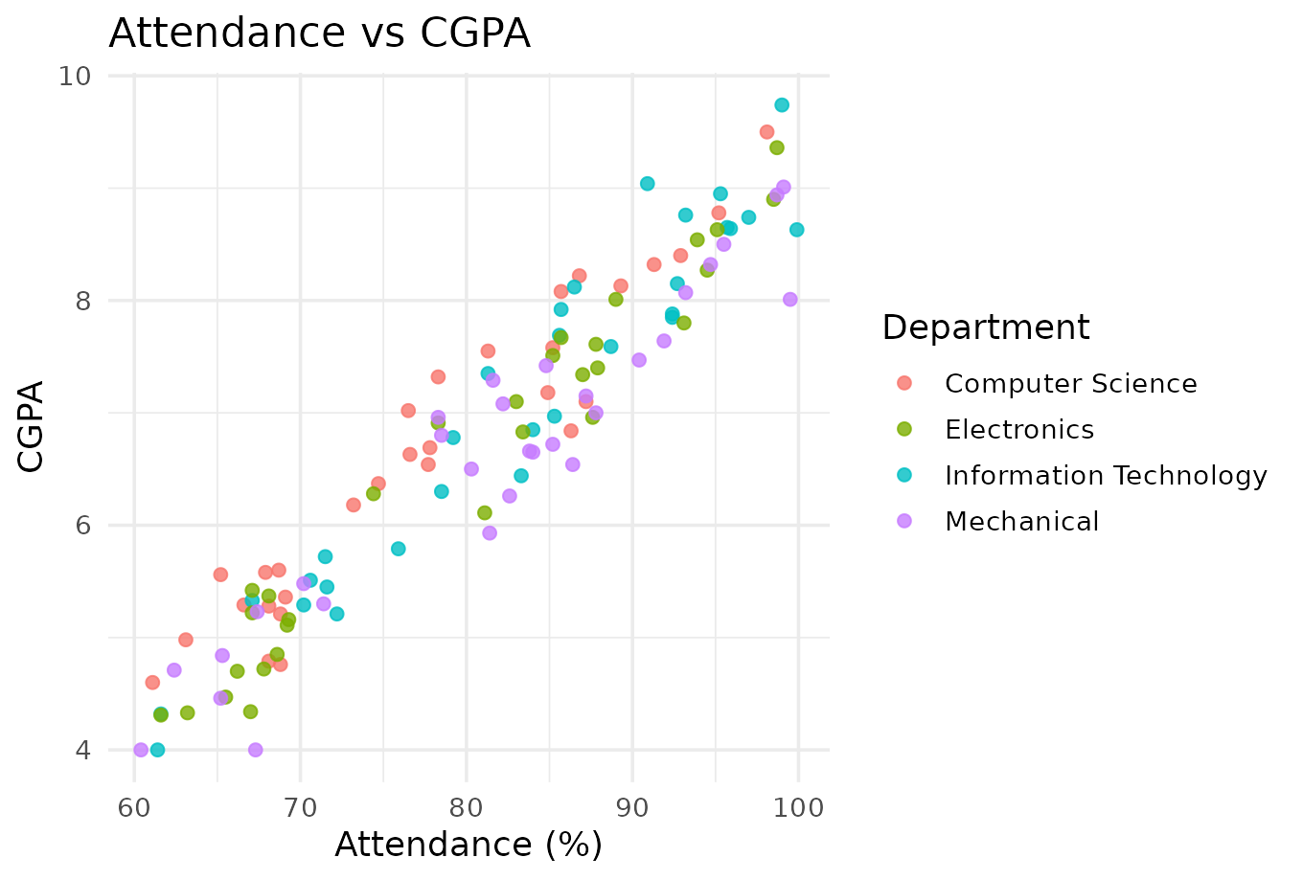 | 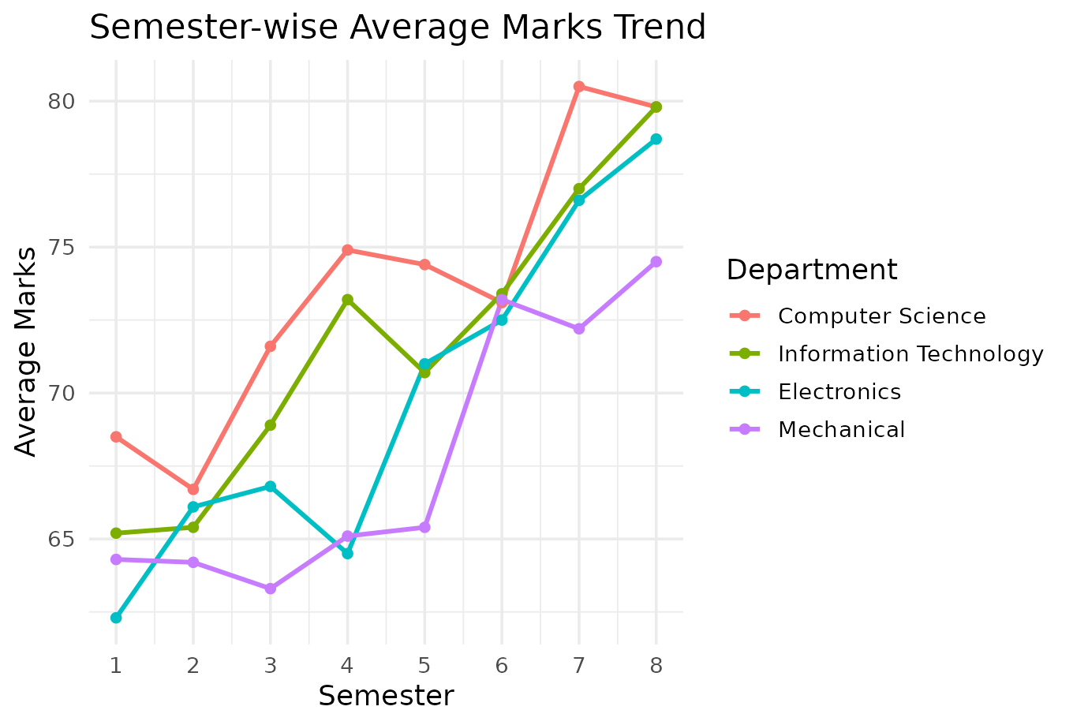
Interpretation
Information Technology recorded the highest average CGPA among the four departments. Attendance and CGPA are strongly positively correlated (r = 0.96). Information Technology also has the highest placement rate at 50%.
Case Study 3 - Hospital Patient Analytics
Visualization Selection
• Heatmap - Compare average treatment cost by department and disease.
• Histogram - Show distribution of treatment costs.
• Violin Plot - Show recovery time distribution by department.
• Density Plot - Show age distribution.
• Scatter Plot - Show age vs recovery time relationship.
R Program
set.seed(303)
departments <- c("Cardiology","Orthopedics","Neurology","General Medicine")
diseases <- c("Cardiac","Fracture","Neurological","Infectious","Respiratory")
n <- 120
patients <- data.frame(Department = sample(departments, n, replace = TRUE),
DiseaseCategory = sample(diseases, n, replace = TRUE, prob = c(0.28,0.18,0.16,0.24,0.14)),
Age = round(runif(n, 18, 80)), AdmissionMonth = sample(month.abb, n, replace = TRUE))
dept_cost_shift <- c("Cardiology"=8000,"Orthopedics"=5000,"Neurology"=7000,"General Medicine"=3000)
patients$TreatmentCost <- round(dept_cost_shift[patients$Department] + runif(n, 1000, 4000))
patients$RecoveryTime <- round(patients$Age * 0.25 + runif(n, 3, 15))
heat_data <- patients %>% group_by(Department, DiseaseCategory) %>% summarise(AvgCost = mean(TreatmentCost))
ggplot(heat_data, aes(DiseaseCategory, Department, fill = AvgCost)) + geom_tile(color = "white") +
geom_text(aes(label = round(AvgCost)), size = 3) + scale_fill_gradient(low = "lightyellow", high = "darkred") +
labs(title = "Avg Treatment Cost by Dept and Disease", x = "Disease", y = "Department")
ggplot(patients, aes(TreatmentCost)) + geom_histogram(binwidth = 1000, fill = "steelblue", color = "black") +
labs(title = "Distribution of Treatment Costs", x = "Cost", y = "Frequency")
ggplot(patients, aes(Department, RecoveryTime, fill = Department)) + geom_violin(trim = FALSE) +
labs(title = "Recovery Time by Department", x = "Department", y = "Recovery Time (days)")
ggplot(patients, aes(Age)) + geom_density(fill = "orange", alpha = 0.5) +
labs(title = "Density Plot of Patient Age", x = "Age", y = "Density")
ggplot(patients, aes(Age, RecoveryTime)) + geom_point(color = "darkgreen") +
geom_smooth(method = "lm", se = FALSE, color = "black") +
labs(title = "Age vs Recovery Time", x = "Age", y = "Recovery Time (days)")
Generated Visualizations
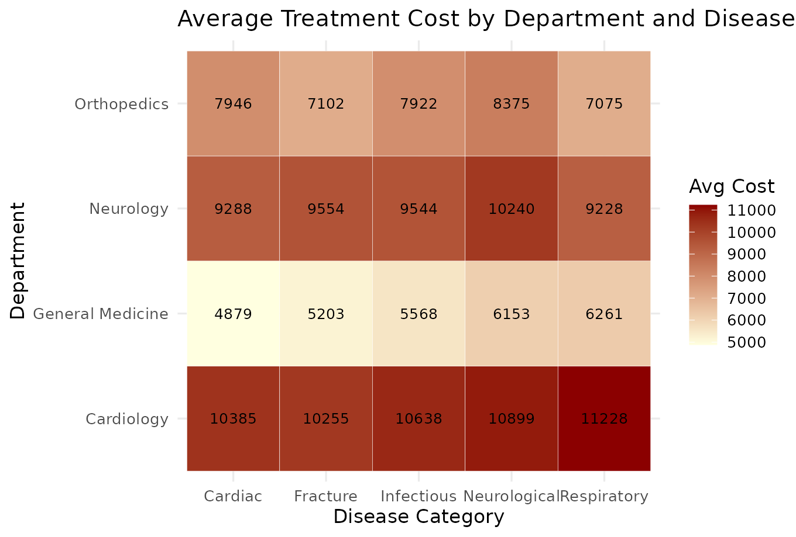 | 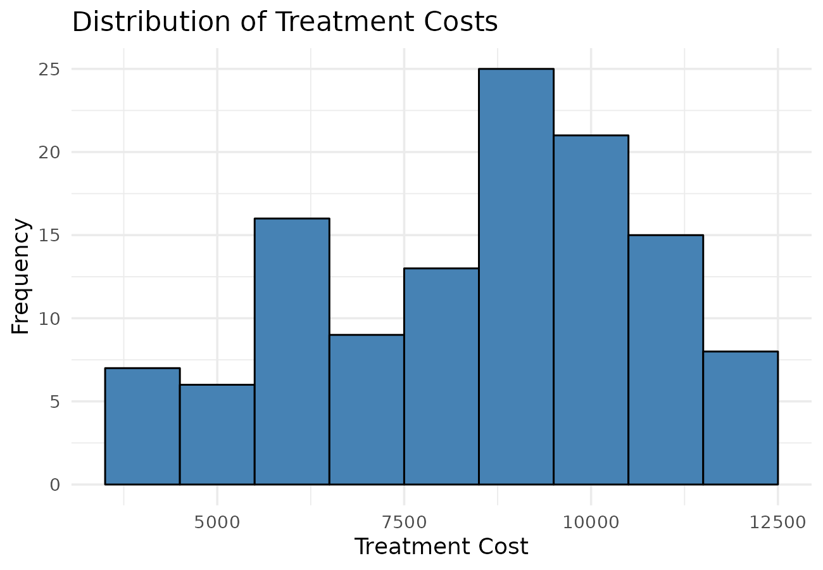
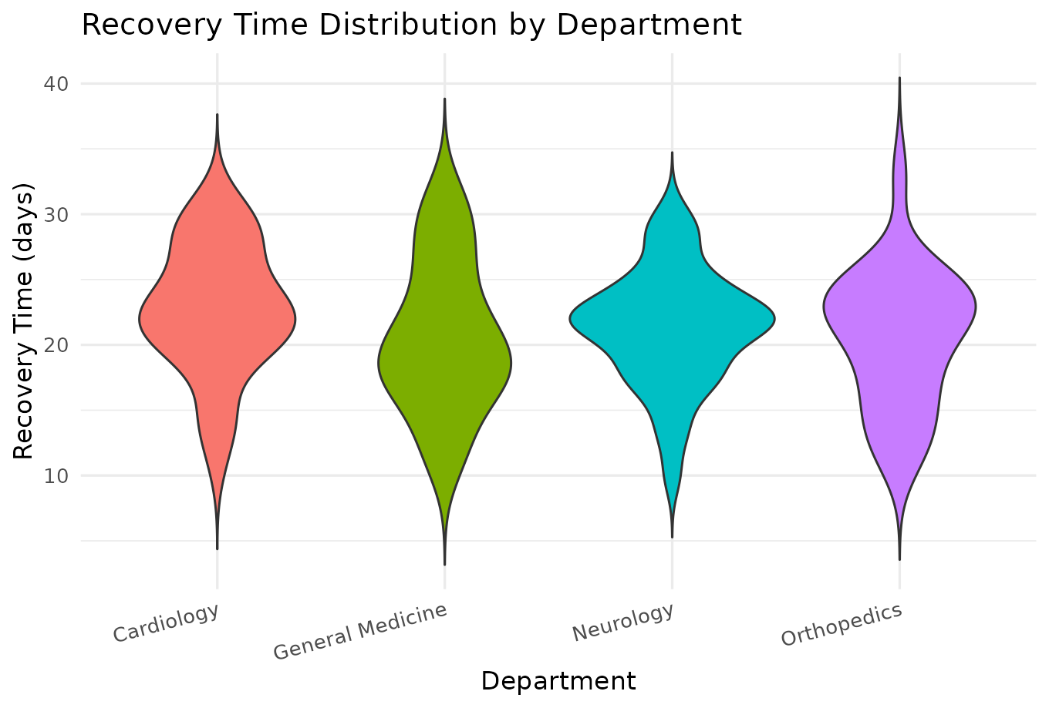
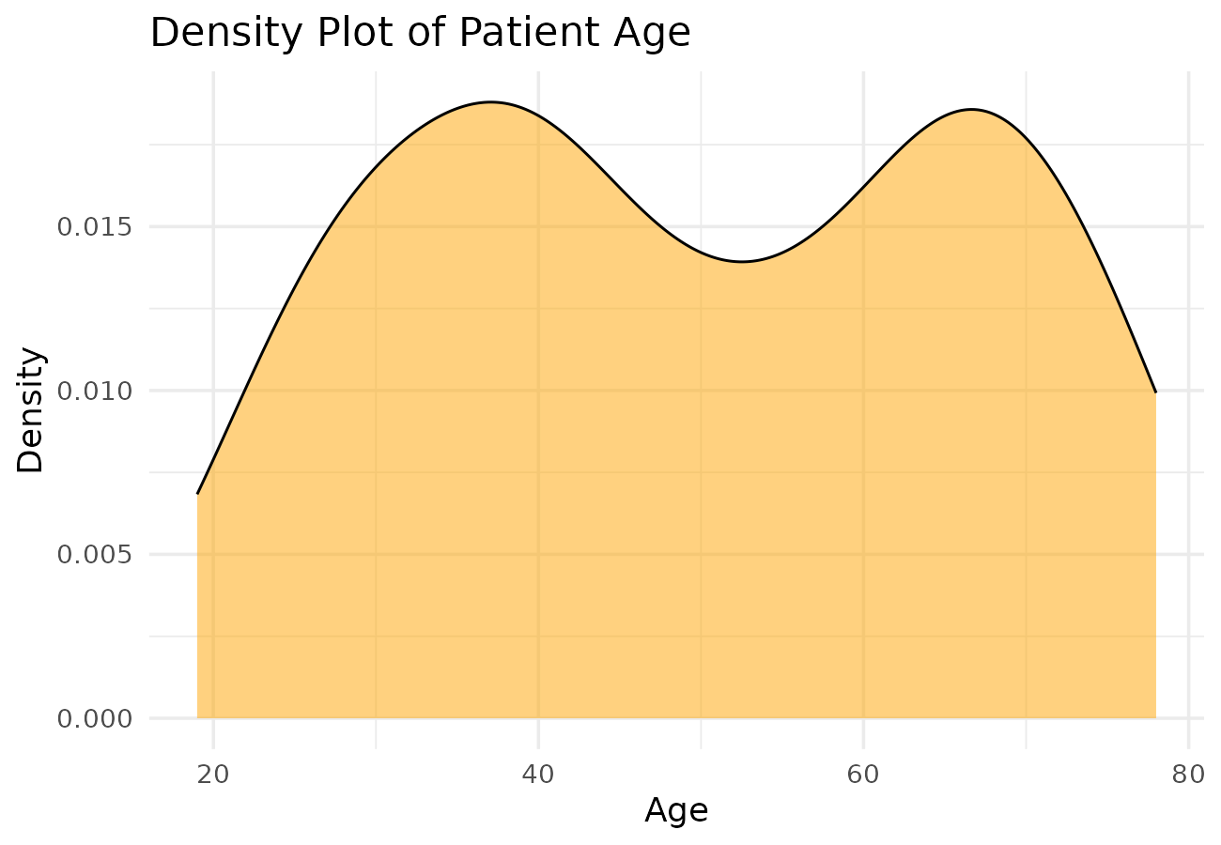 | 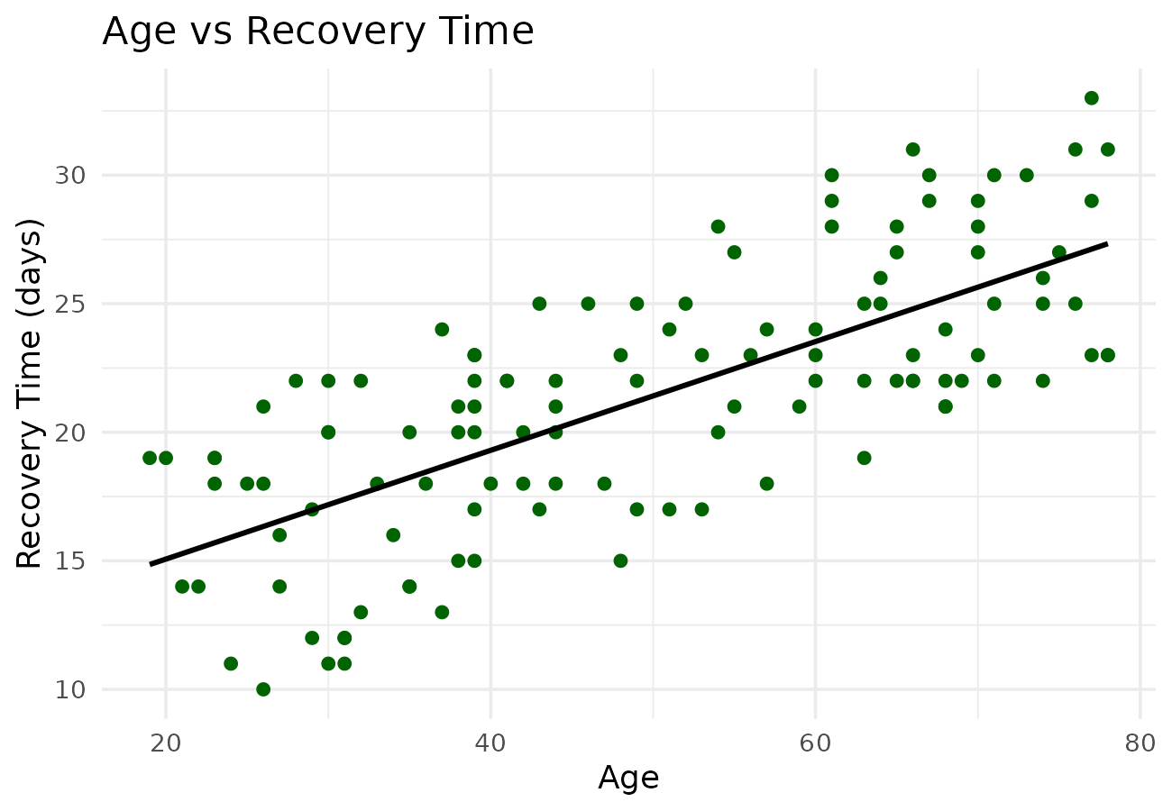
Interpretation
Cardiology has the highest average treatment cost among the four departments. Cardiac cases form the largest disease category at about 27% of admissions. Age and recovery time are positively correlated (r = 0.72).
Case Study 4 - Smart City Traffic Monitoring
Visualization Selection
• Bar Plot - Compare vehicle count across junctions.
• Line Chart - Show hourly traffic trend.
• Pie Chart - Show vehicle type proportion.
• Geospatial Map - Show traffic density by junction location.
• Scatter Plot - Show traffic volume vs average speed relationship.
R Program
set.seed(404)
junctions <- data.frame(Junction = c("J1-AnnaNagar","J2-TNagar","J3-Guindy","J4-Adyar","J5-Velachery","J6-Egmore"),
Lat = c(13.085,13.041,13.010,13.006,12.979,13.077), Lon = c(80.210,80.233,80.220,80.257,80.221,80.261))
hours <- 0:23
traffic <- expand.grid(Junction = junctions$Junction, Hour = hours)
peak_pattern <- 40 + 60*exp(-((traffic$Hour-9)^2)/8) + 70*exp(-((traffic$Hour-18)^2)/8)
traffic$VehicleCount <- round(peak_pattern + runif(nrow(traffic), -10, 10))
traffic$VehicleCount[traffic$Junction=="J2-TNagar"] <- round(traffic$VehicleCount[traffic$Junction=="J2-TNagar"]*1.3)
traffic$AvgSpeed <- round(60 - traffic$VehicleCount*0.25 + rnorm(nrow(traffic), 0, 3), 1)
vehicle_types <- data.frame(VehicleType = c("Car","Two-Wheeler","Bus","Truck","Auto"), Count = c(4200,5600,800,600,1800))
junction_total <- traffic %>% group_by(Junction) %>% summarise(TotalVehicles = sum(VehicleCount))
ggplot(junction_total, aes(reorder(Junction,-TotalVehicles), TotalVehicles, fill = Junction)) + geom_bar(stat="identity") +
labs(title = "Total Vehicles by Junction", x = "Junction", y = "Total Vehicles")
hourly <- traffic %>% group_by(Hour) %>% summarise(AvgVehicles = mean(VehicleCount))
ggplot(hourly, aes(Hour, AvgVehicles)) + geom_line(color="steelblue") + geom_point(color="darkred") +
labs(title = "Hourly Traffic Trend", x = "Hour", y = "Avg Vehicle Count")
ggplot(vehicle_types, aes("", Count, fill = VehicleType)) + geom_bar(stat="identity", width=1, color="white") +
coord_polar("y") + labs(title = "Vehicle Type Proportion")
map_data <- junctions %>% left_join(junction_total, by = "Junction")
ggplot(map_data, aes(Lon, Lat)) + geom_point(aes(size = TotalVehicles, color = TotalVehicles)) +
geom_text(aes(label = Junction), vjust = -1.2, size = 3) + scale_color_gradient(low="yellow", high="red") +
labs(title = "Traffic Density by Location", x = "Longitude", y = "Latitude")
ggplot(traffic, aes(VehicleCount, AvgSpeed)) + geom_point(color="darkgreen", alpha=0.6) +
geom_smooth(method="lm", se=FALSE, color="black") + labs(title = "Traffic Volume vs Speed", x = "Vehicle Count", y = "Avg Speed")
Generated Visualizations
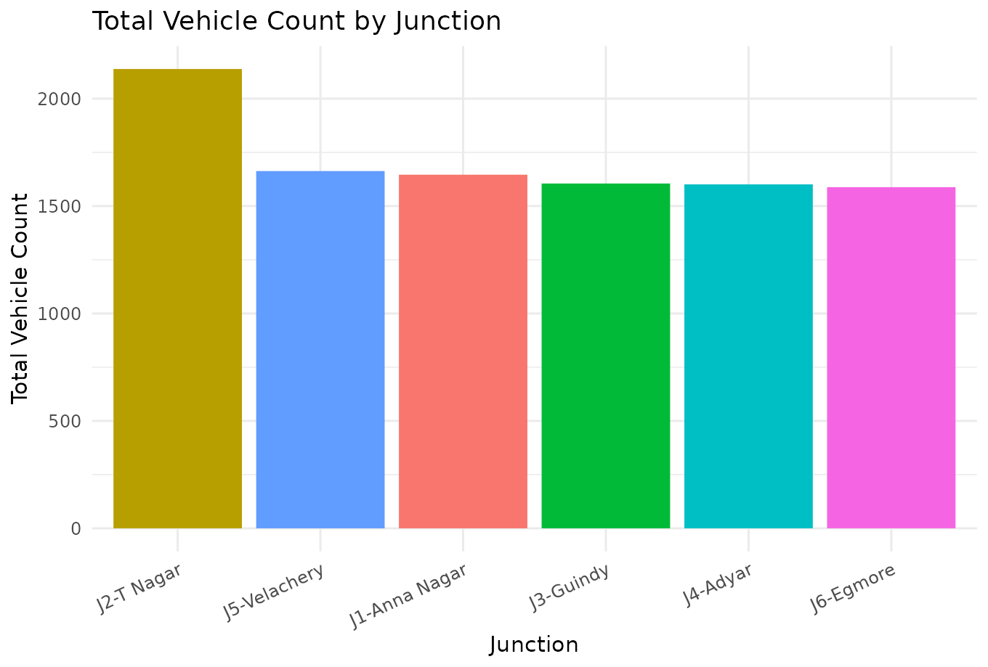 | 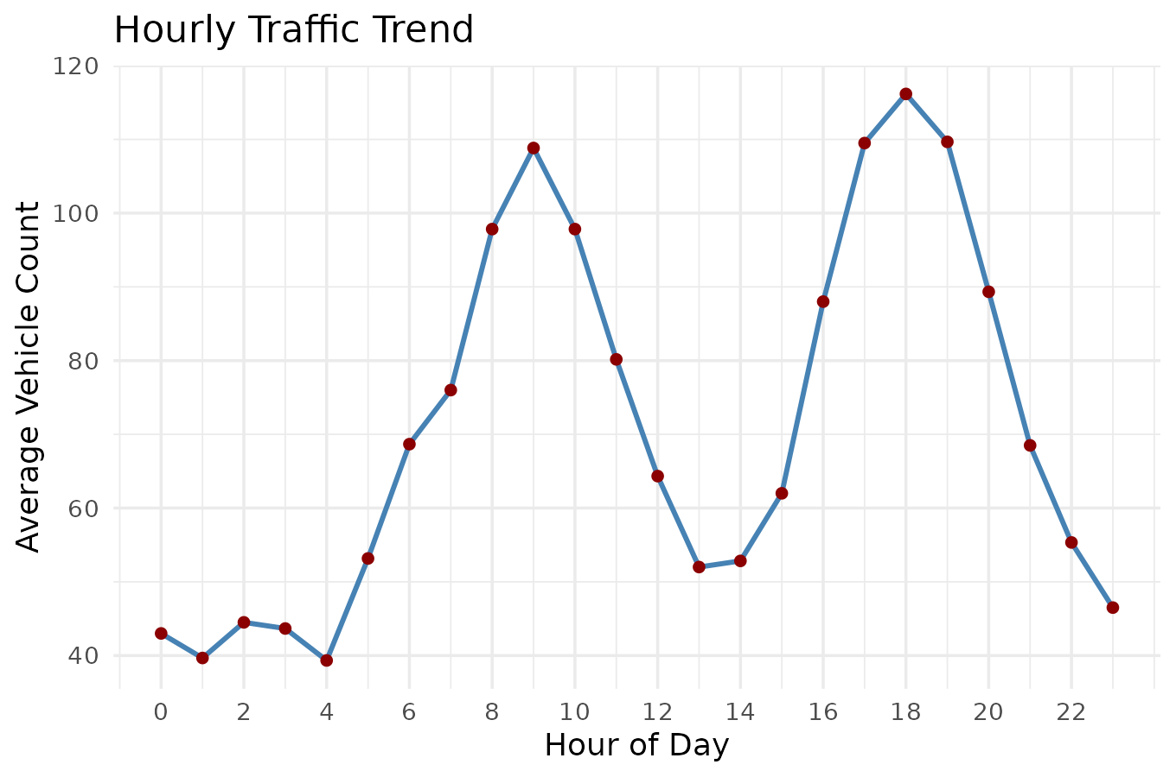
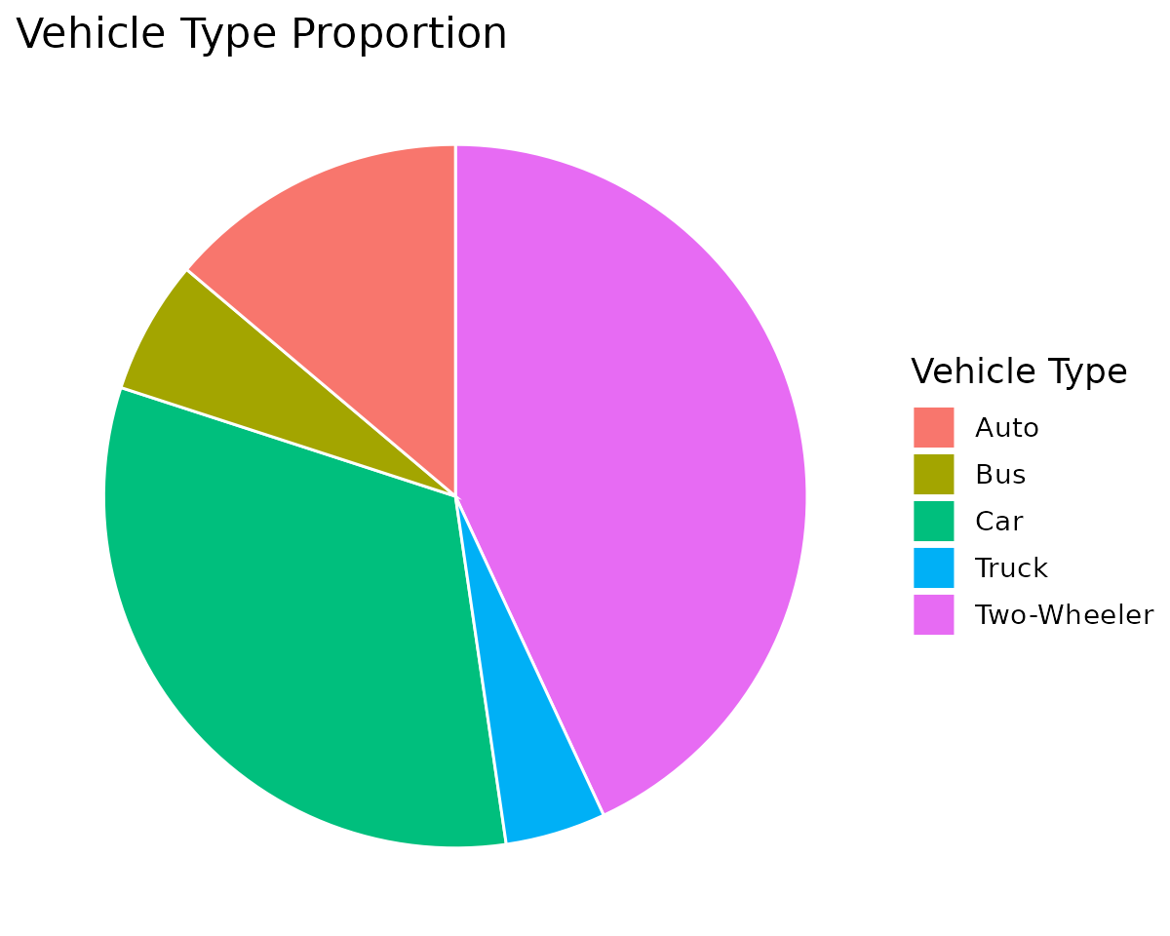
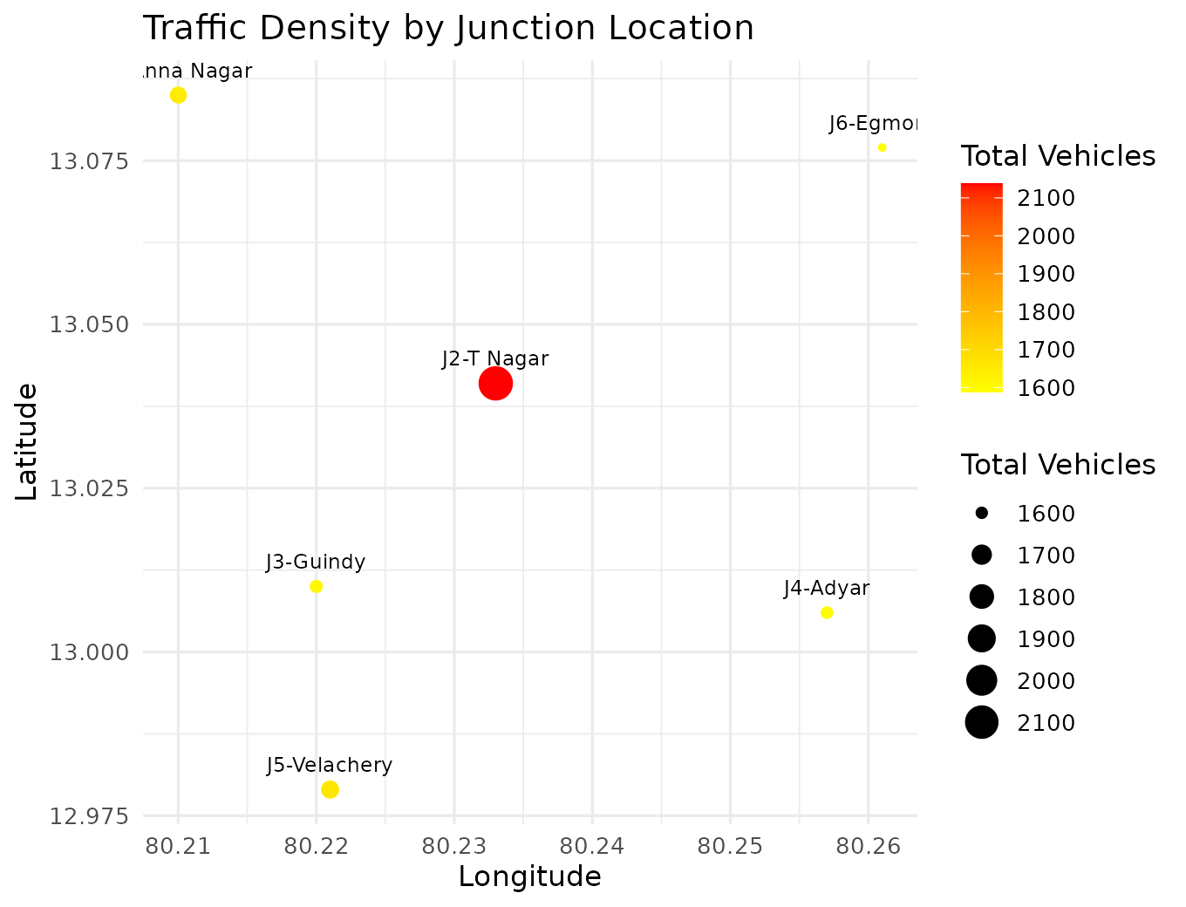 | 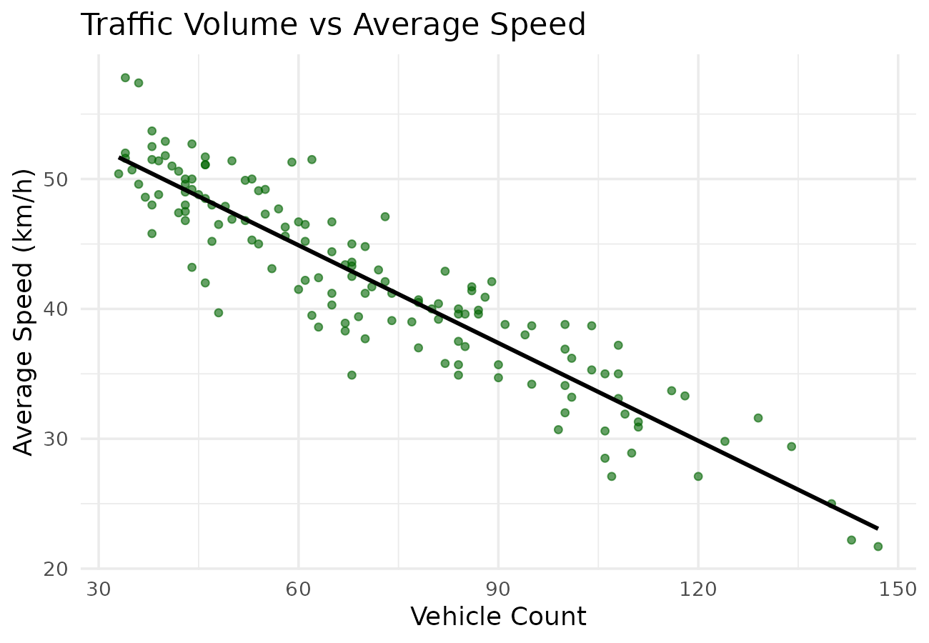
Interpretation
J2-T Nagar experiences the highest congestion with the highest total vehicle count. Traffic peaks between 5 PM and 8 PM during the evening rush. Vehicle count and average speed are strongly negatively correlated (r = -0.92).
Case Study 5 - Social Media User Interaction Analysis
Visualization Selection
• Histogram with Density Curve - Show distribution of likes.
• Scatter Plot - Show followers vs engagement relationship.
• Network Visualization - Show user interaction network.
• Temporal Line Plot - Show posting activity over time.
• Heatmap - Compare likes, shares and comments across users.
R Program
set.seed(505)
n_users <- 15
users <- data.frame(UserID = paste0("U", 1:n_users), Followers = round(rlnorm(n_users, meanlog=8, sdlog=1.2)))
users$Likes <- round(users$Followers * runif(n_users, 0.02, 0.08))
users$Shares <- round(users$Likes * runif(n_users, 0.05, 0.2))
users$Comments <- round(users$Likes * runif(n_users, 0.03, 0.15))
users$Engagement <- users$Likes + users$Shares + users$Comments
posts <- data.frame(Hour = 0:23)
posts$PostCount <- round(5 + 15*exp(-((posts$Hour-20)^2)/10) + 8*exp(-((posts$Hour-13)^2)/6) + runif(24,0,3))
edges <- data.frame(From = c("U1","U1","U1","U2","U2","U3","U3","U4","U5","U5","U6","U7","U8","U8","U9","U10","U1","U3"),
To = c("U2","U3","U4","U3","U5","U5","U6","U6","U6","U7","U7","U8","U9","U10","U10","U11","U9","U8"))
ggplot(users, aes(Likes)) + geom_histogram(aes(y = after_stat(density)), binwidth = 100, fill = "skyblue", color = "black") +
geom_density(color = "darkred") + labs(title = "Distribution of Likes", x = "Likes", y = "Density")
ggplot(users, aes(Followers, Engagement)) + geom_point(color="darkorange") +
geom_smooth(method="lm", se=FALSE, color="black") + labs(title = "Followers vs Engagement", x = "Followers", y = "Engagement")
g <- graph_from_data_frame(edges, directed = FALSE, vertices = users$UserID)
deg <- degree(g)
plot(g, vertex.size = 8 + deg*3, vertex.color = "lightblue", vertex.label.color = "black", main = "User Interaction Network")
ggplot(posts, aes(Hour, PostCount)) + geom_line(color="steelblue") + geom_point(color="darkred") +
labs(title = "Posting Activity Over Time", x = "Hour", y = "Number of Posts")
scaled <- users[, c("UserID","Likes","Shares","Comments")]
scaled$Likes <- scale(scaled$Likes); scaled$Shares <- scale(scaled$Shares); scaled$Comments <- scale(scaled$Comments)
melted <- melt(scaled, id.vars = "UserID")
ggplot(melted, aes(variable, UserID, fill = value)) + geom_tile(color="white") +
scale_fill_gradient2(low="blue", mid="white", high="red", midpoint=0) + labs(title = "Engagement Heatmap", x = "Metric", y = "User")
Generated Visualizations
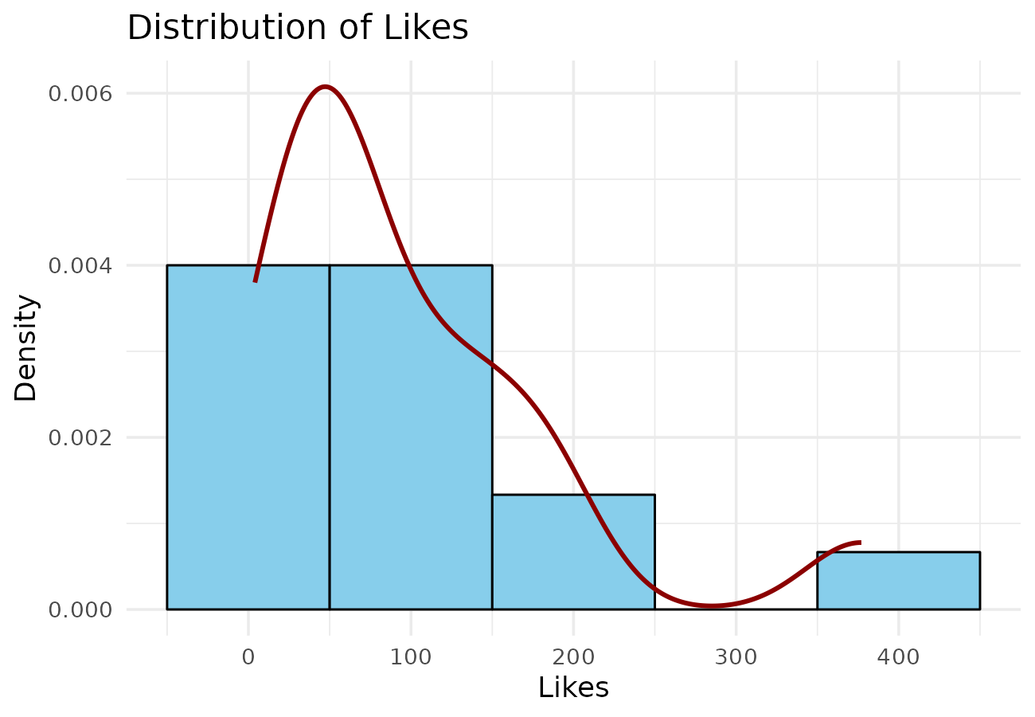 | 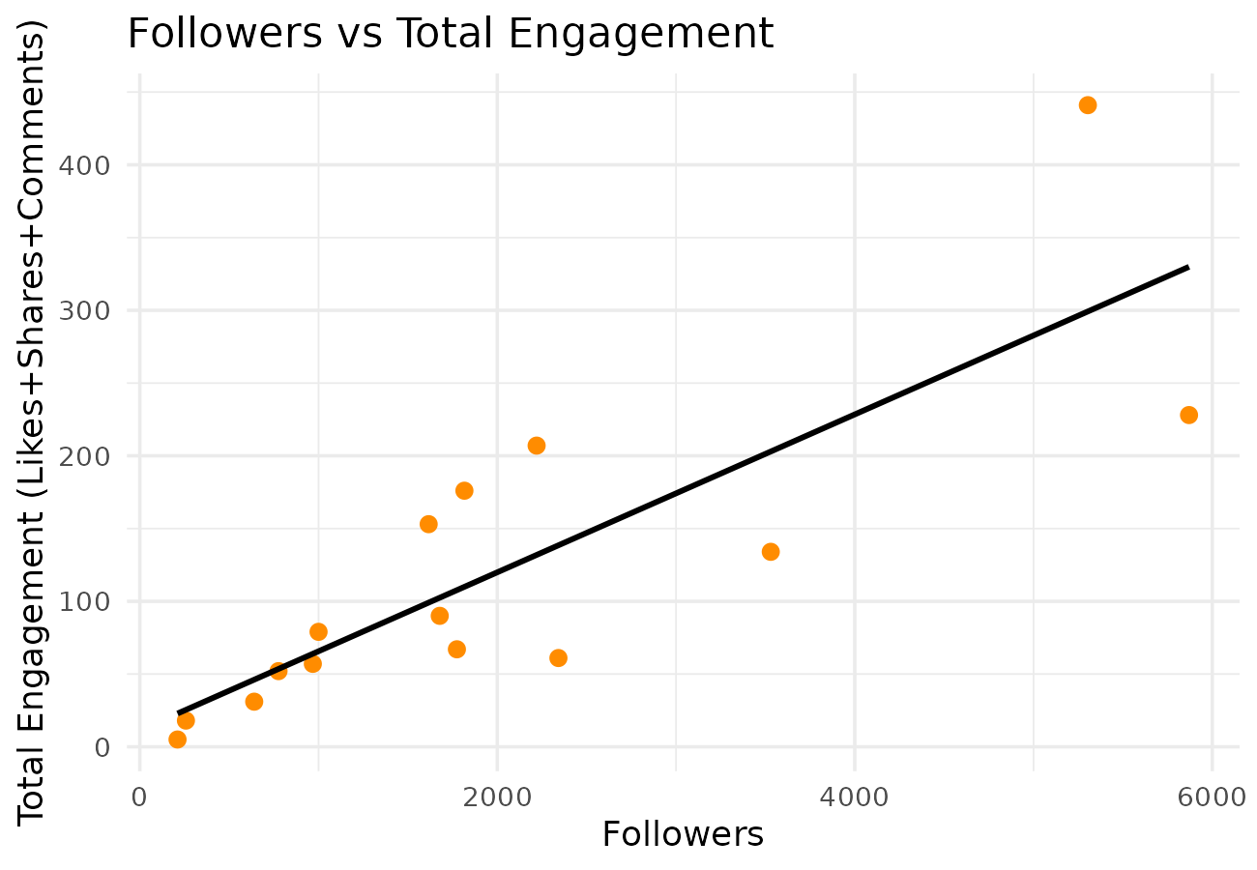
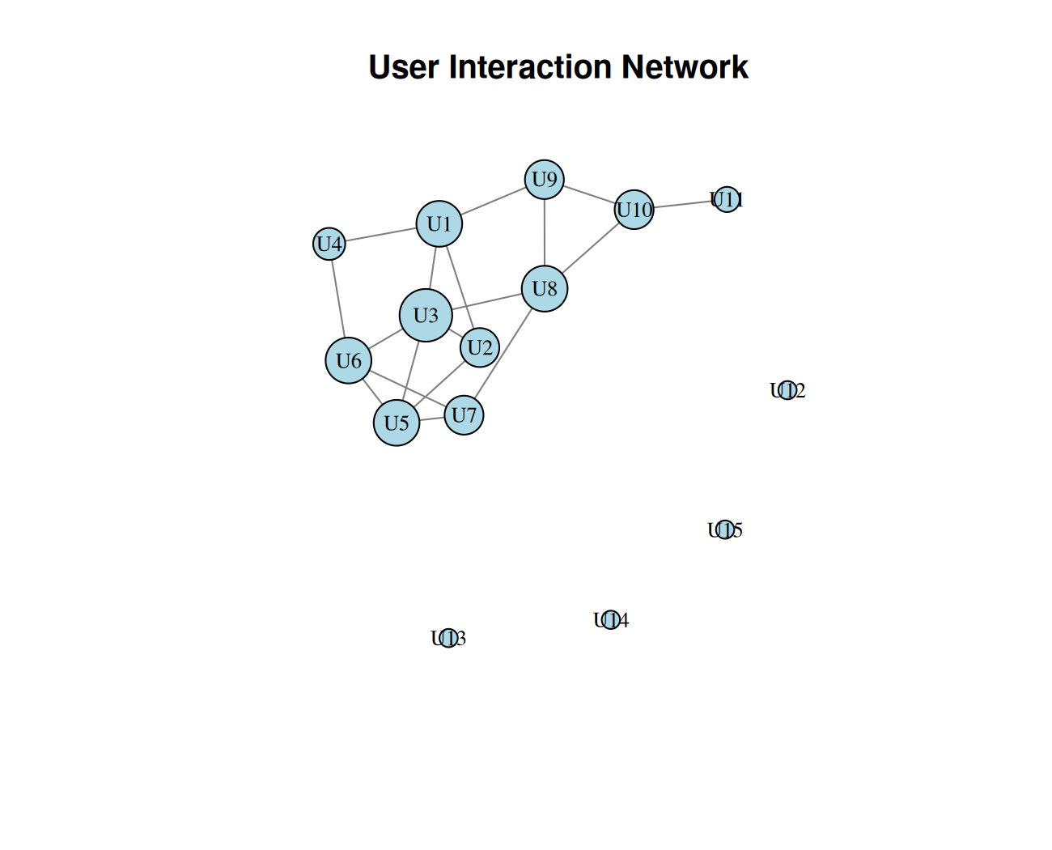
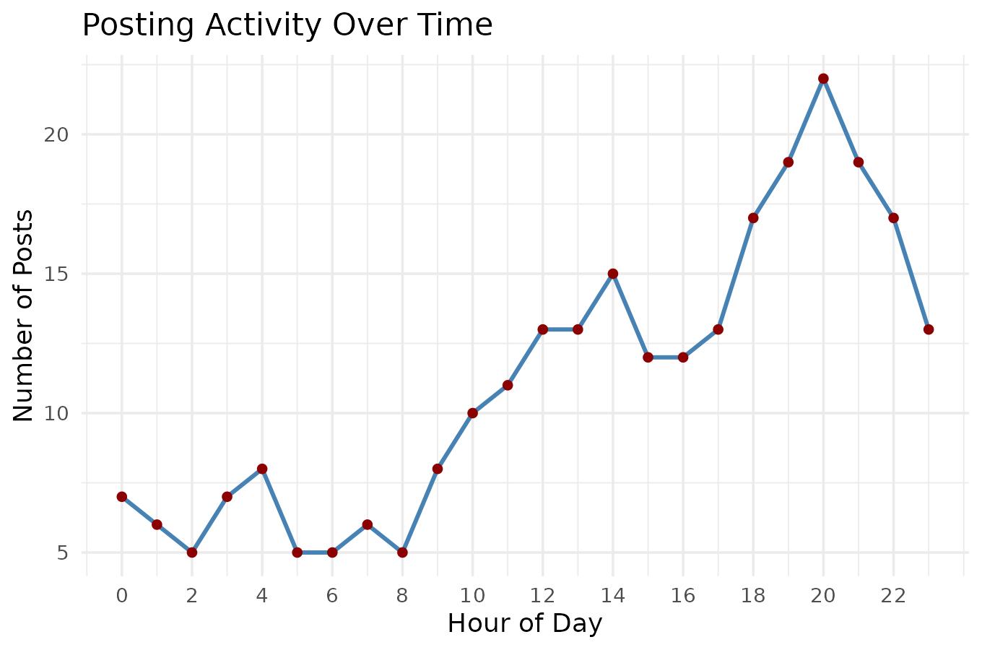 | 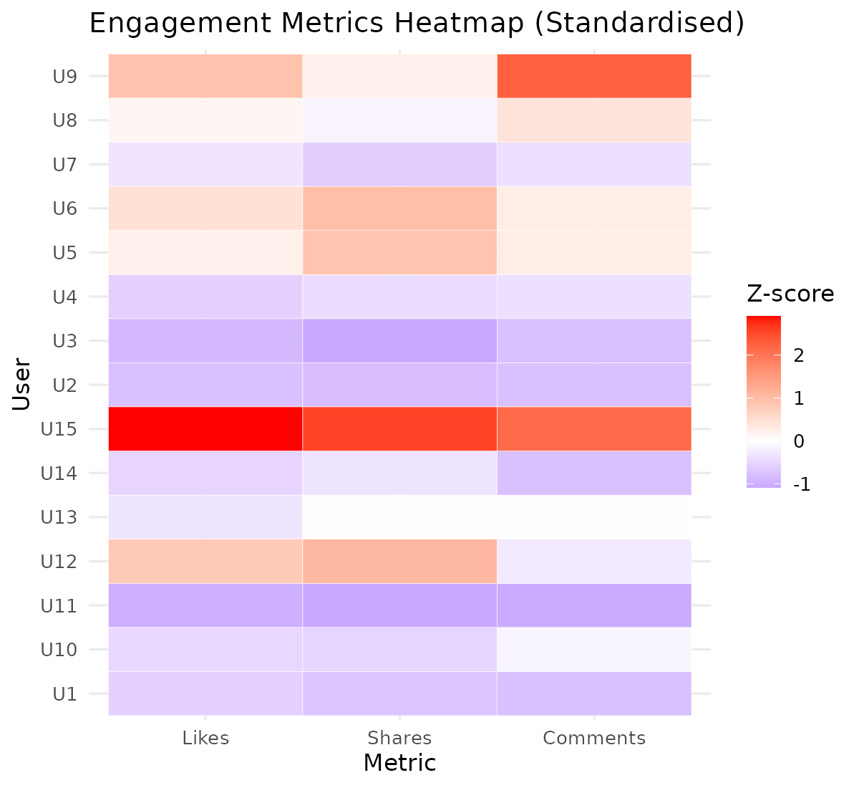
Interpretation
U15 and U9 are the most influential users with the highest engagement, and engagement peaks around 8-9 PM. Followers and total engagement are strongly correlated (r = 0.82), and U3, U1, U5, and U6 are the most highly connected users in the network. Likes is the most variable engagement metric across users.

